Disorder, Difference or Gap: A School-Age Disability Evaluation

Learning Outcomes
- Identify important factors to consider when making a differential diagnosis of speech and
language impairments when assessing school-age children.
- Identify a variety of assessment materials and that can assist in the differential diagnosis analysis of school-age children and examine how to appropriately use those materials with students from certain backgrounds.
- Demonstrate knowledge of ASHA practice portals and evidence-based practice concerning school-age disability evaluations.
- Demonstrate knowledge of ASHA practice portals and evidence-based practice concerning the assessment of students from culturally and linguistically diverse populations.

Course Description
This course identified important factors to consider when making a differential diagnosis of speech and language impairments when assessing school-age children, using a variety of assessment materials to assist in the differential diagnosis analysis. This course demonstrated that a child’s language and dialect acquisitional history, educational history, and parent and teacher interviews are important considerations in reaching a differential diagnosis. Participants demonstrated knowledge of ASHA practice portals and evidence-based practice concerning school-age disability evaluations and assessing culturally and linguistically diverse populations.

Course Outline
Participants review the video modules and the readings and then take the written assessment. The topics of the video modules are to be completed in the following order:
- Module 1: Language Acquisitional History, Family History, and Educational Background
- Module 2: Academic Performance and Teacher Interview
- Module 3: Student-Evaluator Clinical Interaction
- Module 4: Analysis and Disability Determination: Disorder, Difference, or Gap?

This course, offered for ASHA CEUs, has no registration fee.

Disclosure
Catherine Crowley, J.D., Ph.D., CCC-SLP has a financial relationship with Teachers College
Columbia University in that she is a salaried faculty member and she receives no additional
financial compensation from this course. Dr. Crowley has no other financial or nonfinancial
relationships.

Dr. Catherine (Cate) Crowley, J.D., Ph.D., CCC-SLP Professor of Practice in Communication Sciences and Disorders at Teachers College Columbia University, founded and directs the bilingual/multicultural program focus and the Bilingual Extension Institute. An experienced attorney, Dr. Crowley works with school districts and state education departments to increase the accuracy of disability evaluations and to identify appropriate supports for students with academic difficulties. An ASHA fellow, Dr. Crowley received ASHA awards for “Contributions to Multicultural Affairs”; “International Achievement”; and “Outstanding contributions to SLP services in schools” and received Honors from the New York State Speech Language and Hearing Association. While on ASHA’s Multicultural Issues Board, Dr. Crowley co-authored the current ASHA practice policy documents on the roles and responsibilities of SLPs in schools.

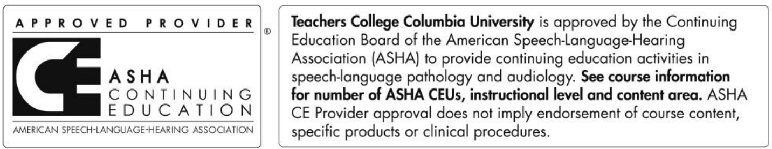

This program is offered for 0.35 ASHA CEUs (Intermediate level; Professional area).

