English Cleft Palate Speech Therapy: Evaluation and Treatment

Learning Outcomes:
- Demonstrate knowledge of anatomy and physiology of the velopharyngeal system and the types of structural abnormalities that occur in children with cleft lip and palate.
- Demonstrate knowledge of the ways in which a cleft palate can affect speech, both pre- and post-surgical repair.
- Identify a variety of assessment tools that can be used to evaluate the speech of children with cleft palate who exhibit different speech characteristics.
- Identify a variety of strategies to elicit high pressure sounds for stimulability testing and treatment in children with cleft palate.
- Demonstrate knowledge of evidence-based treatment approaches for children with different types of compensatory cleft palate speech errors.

Course Description:
This self-study course focuses on speech and feeding in cleft palate cases. Participants will learn about evidence-based assessment and treatment approaches for children with various compensatory cleft palate speech errors. Topics include speech therapy, oral examination and speech sound assessment, feeding a baby with cleft lip and/or cleft palate, syndromes, and surgical cleft palate repair.

Course Outline:
Participants review the video modules and the readings and then take the written assessment. The topics of the video modules are to be completed in the following order:
- Module 1.1: Importance of Speech Therapy and Introduction to Anatomy (10:51)
- Module 1.2: Anatomy and Physiology of Cleft Lip and Palate (7:40)
- Module 1.3: Submucous Cleft, Occult Palate Anatomy and Physiology (8:47)
- Module 1.4: Nasopharyngeal Closure and Nasoendoscopy (8:43)
- Module 2.1: How Speech Sounds are Made (26:42)
- Module 2.2: Resonance (5:27)
- Module 3.1: Oral Examination and Speech Sound Assessment (16:27)
- Module 3.2: Cleft Palate Speech Therapy Strategies (24:50)
- Module 3.3: Addressing Nasal Emissions in Cleft Palate Speech (8:38)
- Module 3.4: Strategies for Eliminating Glottal Stops (18:49)
- Module 3.5: Therapy for Cleft Palate Speech Errors (19:33)
- Module 3.6: Cleft Palate Speech Therapy Hierarchy (11:27)
- Module 3.7: Why Non-Speech Oral Motor Exercises Don’t Work (6:24)
- Module 4.1: Feeding a Baby with Cleft Lip and/or Cleft Palate (7:07)
- Module 4.2: Addressing Speech and Language Before Surgery (11:29)
- Module 5: Syndromes: Treacher Collins, 22q11.2 Deletion, Pierre Robin, Moebius (9:57)
- Module 6: Surgical Cleft Palate Repair: Primary, Secondary, VPI Surgery, Fistulas (18:17)

This course, offered for ASHA CEUs, has no registration fee.

Disclosure
Catherine Crowley, J.D., Ph.D., CCC-SLP has a financial relationship with Teachers College
Columbia University in that she is a salaried faculty member and she receives no additional
financial compensation from this course. Dr. Crowley has no other financial or nonfinancial
relationships.

Dr. Catherine (Cate) Crowley, J.D., Ph.D., CCC-SLP Professor of Practice in Communication Sciences and Disorders at Teachers College Columbia University, founded and directs the bilingual/multicultural program focus and the Bilingual Extension Institute. An experienced attorney, Dr. Crowley works with school districts and state education departments to increase the accuracy of disability evaluations and to identify appropriate supports for students with academic difficulties. An ASHA fellow, Dr. Crowley received ASHA awards for “Contributions to Multicultural Affairs”; “International Achievement”; and “Outstanding contributions to SLP services in schools” and received Honors from the New York State Speech Language and Hearing Association. While on ASHA’s Multicultural Issues Board, Dr. Crowley co-authored the current ASHA practice policy documents on the roles and responsibilities of SLPs in schools.
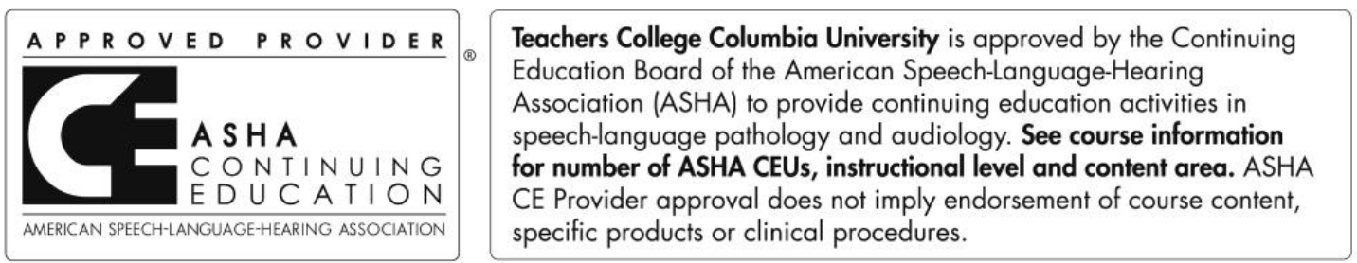
This program is offered for 0.50 ASHA CEUs (Intermediate level; Professional area).

